Computer Networks (CS 3001)  Date: 26th June, 2024  Course Instructor(s)  Dr. Ghufran Ahmed, Dr. Aqsa Aslam,  Dr. Farrukh Salim, Dr. Nausheen Shoaib,  Ms Yusra Kaleem, Ms Hira Tunio,  Ms Rafia Shaikh and Mr Muhammad Usman | Re-Final Exam  Total Time (min): 180  Total Marks: 100  Total Questions: 5
___________ __________ | _____________________
Roll No Section | Student Signature
Do not write below this line.

Attempt all the questions.
CLO # 1: Describe and evaluate the protocols, services and functions provided by each layer in the Internet protocol stack

Q1. a). A user has to perform different tasks using internet, as shown in Table 1. The user has to specify the transport service requirements in terms of (i) loss tolerance (ii) throughput and (iii) delay tolerance. Redraw the Table 1 in answer sheet and select the most appropriate one: (10)

Application | Some data loss is ok or not  (1 mark each) | Is there any minimum throughput required (yes/No) (0.5 mark each) | Time sensitive task? Service with some delay is ok or not. (1 mark each)
Uploading an image on a webpage | Ok / No | Yes / No | Ok / No
Video chat on Google Meet | Ok / No | Yes / No | Ok / No
Playing an online interactive game. | Ok / No | Yes / No | Ok / No
Watching a video | Ok / No | Yes / No | Ok / No

Table 1. Transport service requirement for various type of traffic
b). Consider a student named Karim who enters the university with his laptop. He is located in room S2 of the Computer Science block. The IT department at the university provides several network services, including DHCP, DNS, file storage, and a web application (e.g., Flex). Explain the steps involved when Karim's laptop:
i. Connects to the Internet, using the four DHCP message exchanges. (2)
ii. Sends a request to flex.nu.edu.pk. (1)
iii. Propose an application-level solution to address the bottleneck caused by multiple users accessing the file storage for CN video lectures. (2)

CLO #2: Apply network protocol and communication services for client/server and other application layouts
Q2. Consider the evolution of TCP's congestion window in Figure 2. You need to draw the table, similar to Table 2 in your answer sheet and then fill in the table entries accordingly. The values of Congestion Window (cwnd ) for each Time Unit are displayed in the Figure 2 (as well as in the Table). For example, the initial value of cwnd is 8, and the initial value of ssthresh (shown as a dotted line) is also 8. The three possible states of congestions are Slow Start, Congestion Avoidance and Fast Recovery, as shown by TCP (Reno) FSM in Figure 1. (20)
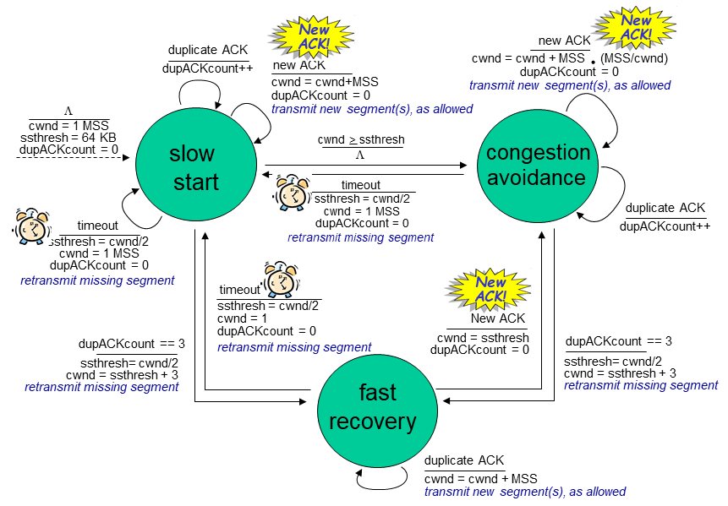

Figure 1. TCP Finite State Machine

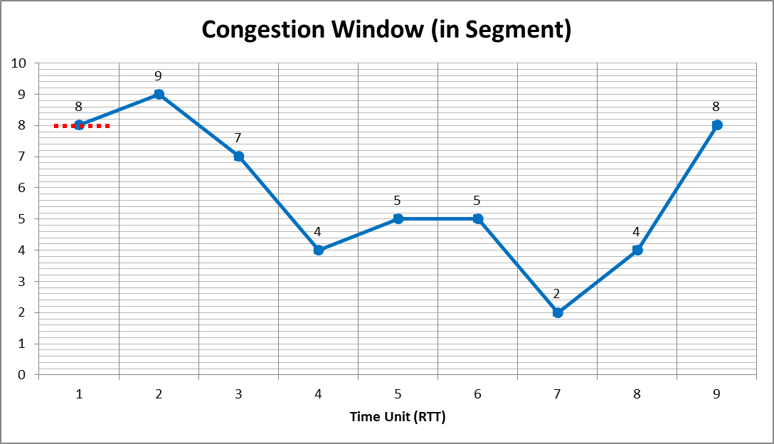

Figure 2. Evolution of TCP's congestion window

Time Unit (RTT) | cwnd | State of Congestion window (1.5 mark each) | ssthresh value (1 mark each)
1 | 8 | slow start | 8
2 | 9
3 | 7
4 | 4
5 | 5
6 | 5
7 | 2
8 | 4
9 | 8

Table 2. cwnd state and ssthresh values

CLO #3: Analyze the architectural principles of computer networking and compare different approaches to organizing networks.

Q3. a). Given that a TCP connection has an estimated RTT of 30 ms with a deviation of 3 ms, what will be the value of the retransmission timer if the next acknowledgment is received after 28 ms? (3)

b). Does UDP need a mechanism to estimate the RTT between the sender and receiver? Provide a brief explanation for your answer. (2)

c). In the given Figure 3, the host PC2 present in NETWORK X has MTU = 800 bytes, and the host PC3 present in NETWORK Y has MTU = 270 bytes. PC2 wants to send a message to PC3.
The IPv4 datagram with an Identification number (ID=123) and header size of 20 bytes will be fragmented into smaller IP datagrams. Discover all fragmented IP datagrams and mention each fragmented datagram using the following fields.
Draw a table similar to Table 3, and clearly mention all fields for each fragmented datagram. (5)
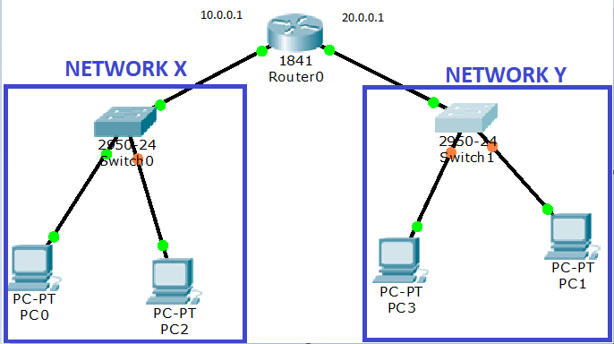

Figure 3. A network with various MTU for different links

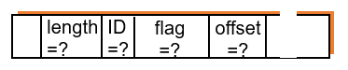

Table 3. Fragmentation fields in IPv4 Header

d). Give short Answers (preferably one line):
i. Why we need to use satellite network, when we already have many high-speed wireless networks, like WiFi for covering small areas, and mobile (cellular) networks for covering large areas. (1)
ii. In (access) networks, same cable is used both for downstream and upstream transmissions, however, the data transmission rates of downstream transmission is usually higher than upstream transmission, how? (2)
iii. Differentiate between interference versus noise in wireless radio. (2)
iv. Assume an organization don’t want to upgrade their devices to IPv6, nor flexible enough to use NAT. In this circumstance, how the devices within the organization can use the internet services? (2)
v. How many maximum numbers of mappings are possible with a single public IPv4 address in a NAT table? (2)
vi: In IPv4 datagram header, Provide all valid values of 4-bit “version” field. (2)
vii. In IPv4 datagram header, which values are invalid of 4-bit “header length” field. (2)
viii. In IPv4 datagram header, what is the purpose of “Time To Live” field. (2)
ix. In IPv4 datagram header, what is the purpose of “upper layer” field. (2)
x. In IPv6 datagram format, provide three 'set of fields' which are missing, compared with Ipv4? (3)

e). Consider the Figure 4, while answering the following questions: (5 * 1 = 5)
i. What is the default gateway of Host1?
ii. What is the Network address of Router R2 Fa0/0?
iii. What is the default Subnet mask of Host2?
iv. How many Subnets are there in the figure?
v. What is the default Subnet mask of class B?
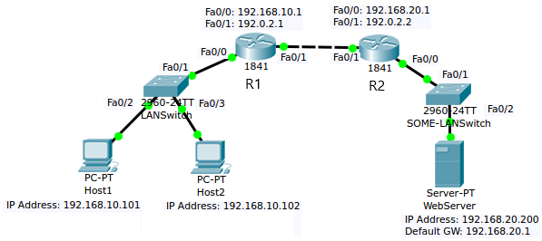

Figure 4. A network comprising various Class C subnets

CLO #3: Analyze the architectural principles of computer networking and compare different approaches to organizing networks.

Q4. a) Differentiate between Link State and Distance Vector routing algorithm, with respect to:
i. message complexity. (2)
ii. robustness. (3)

b). Describe in 1-2 sentence each, the following properties of Discuss vector algorithm:
i. iterative, asynchronous (2)
ii. distributed, self-stopping (3)

c). List names of at-least three routing protocols of intra-AS (intra Autonomous System). (3)

d). Consider the network comprising of three Autonomous Systems, shown in Figure 5. Identify the router(s), where iBGP routing protocol is not running. (2)
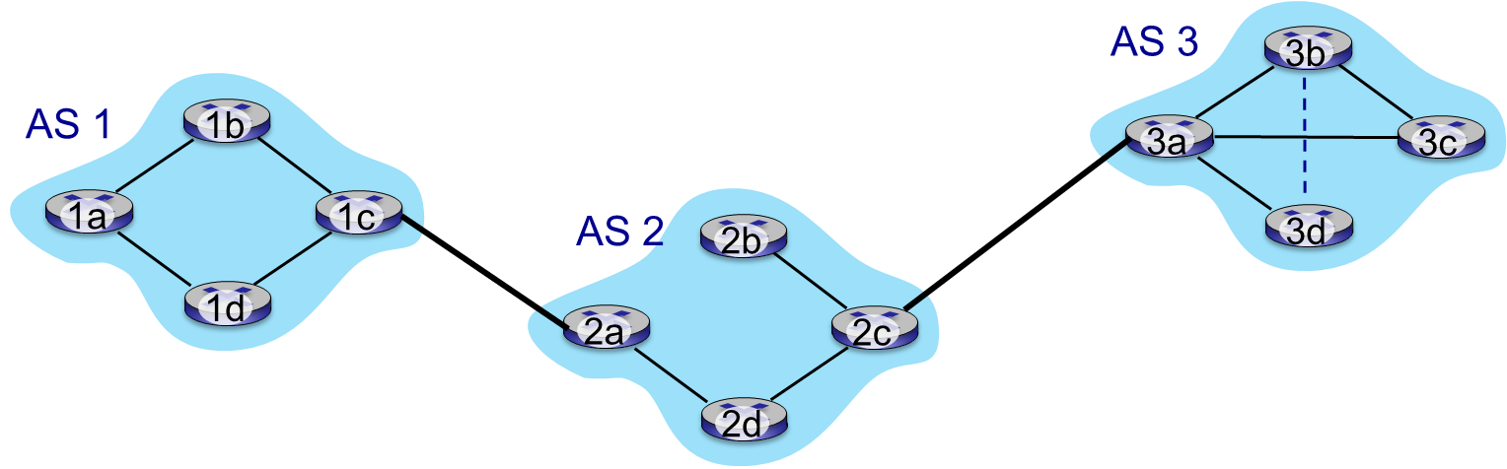

Figure 5. An example internet consisting of various autonomous systems

CLO #3: Analyze the architectural principles of computer networking and compare different approaches to organizing networks.

Q5. a). Polling and token passing are the two protocols used for Medium Access Control (MAC).
i. Discuss in 1-2 sentence the working mechanism of the two protocols. (2)
ii. Provide the disadvantages of each. (3)

b). Given the following 4x4 data matrix, calculate the row and column parity bits to create a 5x5 matrix with even parity: (5)
1 0 1 1
0 1 1 0
1 1 0 0
0 0 1 1

c). A Data word 11100 is transmitted over a channel with CRC error detection code. Generate the CRC codeword at the sender side using a divisor 1001. (5)

